To Supply Leftover Food To Poor

**College Name: Shri Nehru Maha Vidyalaya College Of Arts & Science.**

**TEAM ID:**  NM2025TMID20698

**TEAM MEMBERS:**

Team LeaderName: **SREETHIKA R**

**Email:** sreethikarajarajeswaran@gmail.com

Team Member: **PRADEESH P**

**Email:** ppradeesh420@gmail.com

Team Member: **SHERIF RAHMAN A**

**Email:** rasirashik21501@gmail.com

Team Member: **PADHMA A**

**Email:** padhmapadhma6603@gmail.com

# 1.INTRODUCTION

## 1.1 Project Overview

The project aims to connect **restaurants, events, and households with surplus food** to **NGOs and volunteers** using Salesforce. The goal is to reduce food wastage and ensure leftover food reaches poor and needy people efficiently.

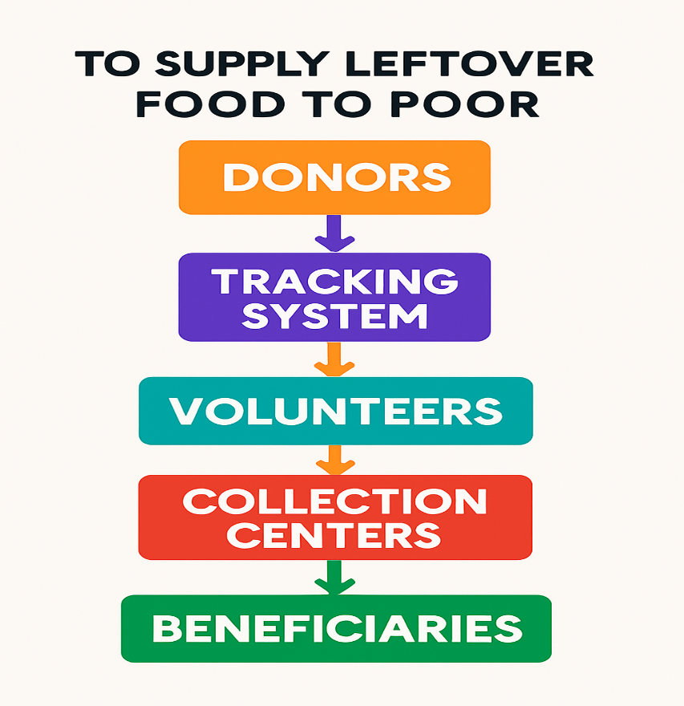

## 1.2 Purpose

• Reduce food wastage by collecting surplus from restaurants, events, and households.

• Distribute leftover food to poor and needy communities efficiently.

• Use Salesforce to track donors, manage drop-off points, and monitor impact.

• Generate dashboards and reports to measure outreach and effectiveness.

• Promote social responsibility by connecting donors, NGOs, and volunteers seamlessly.

# DEVELOPMENT PHASE

**Creating Developer Account:**

By using this URL[**- https://www.salesforce.com/form/developer-signup/?d=pb**](https://www.salesforce.com/form/developer-signup/?d=pb)

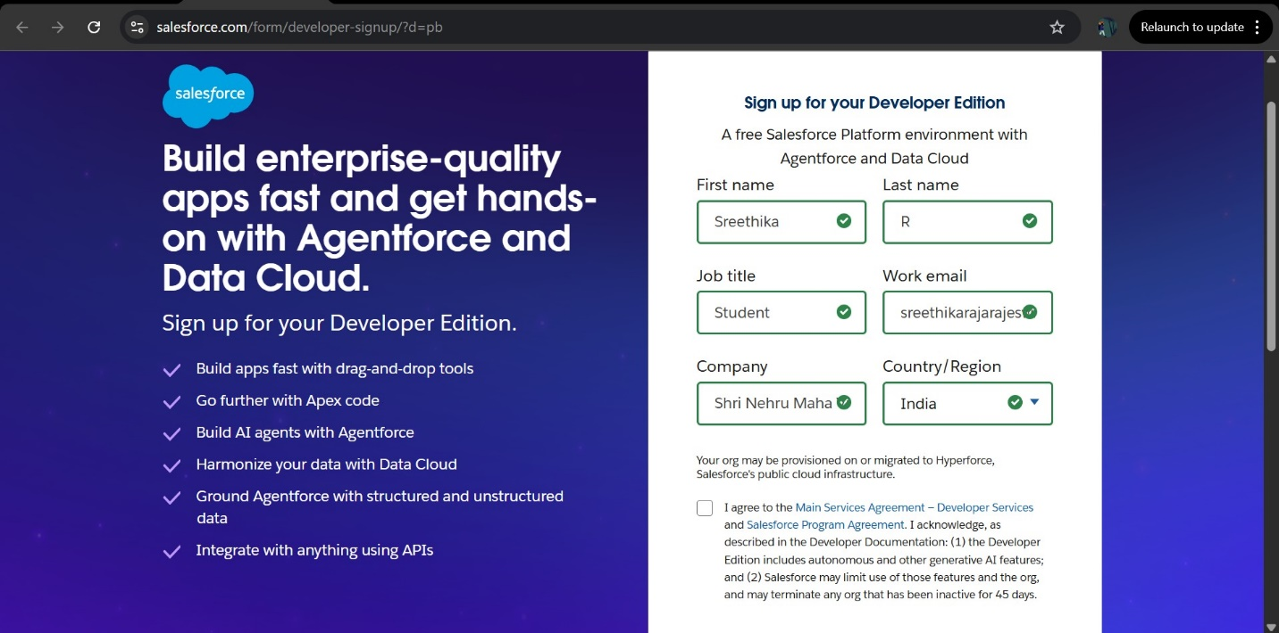

OBJECT:

* **Created Objects:**
* Venue
* Drop-Off Point
* Task
* Volunteer
* Execution Detail

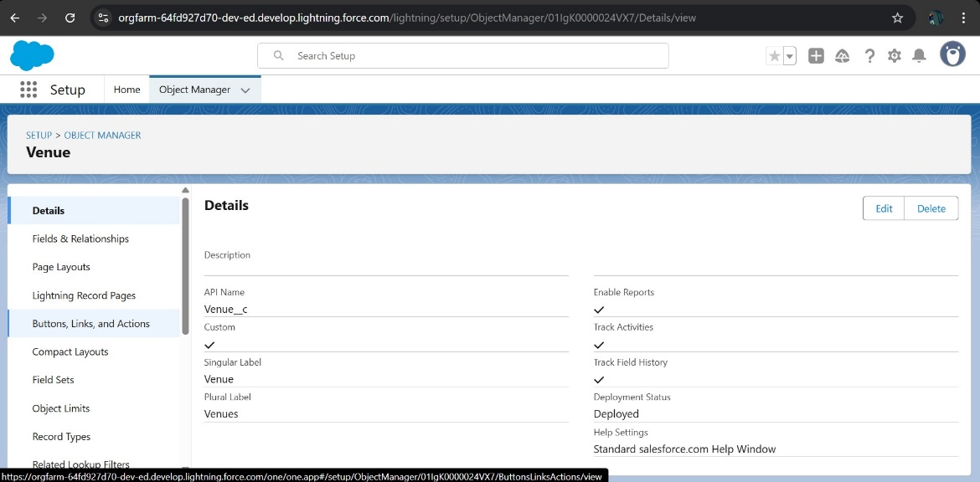

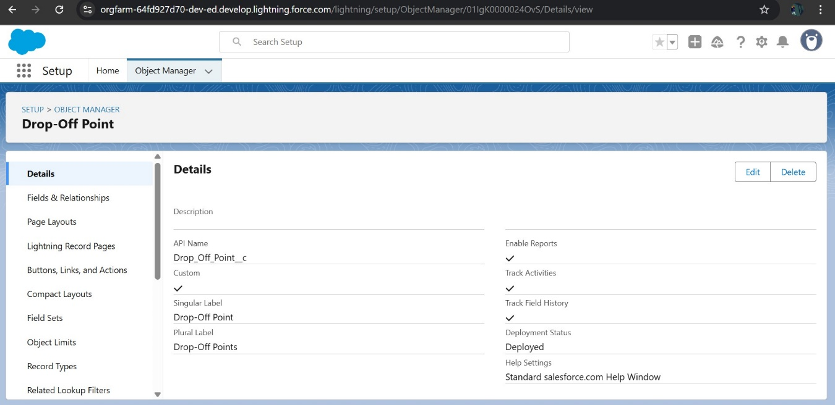

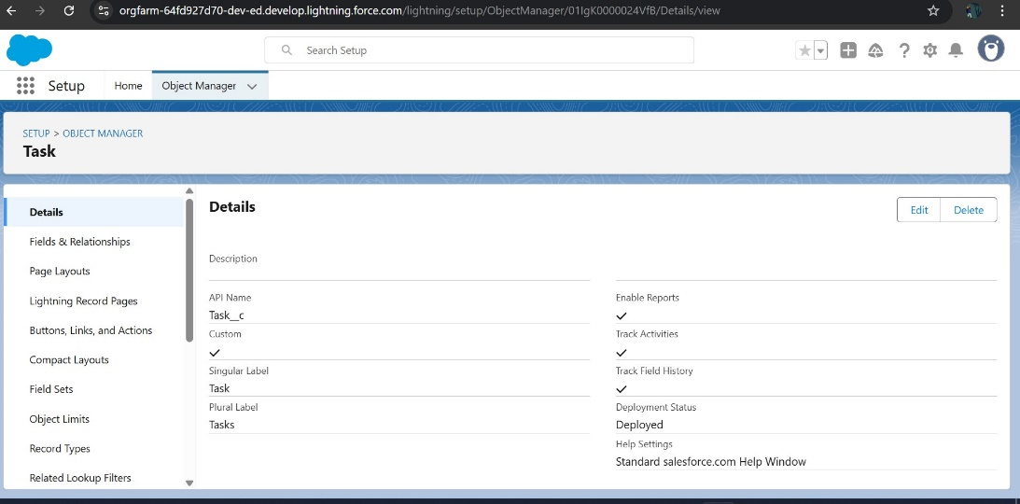

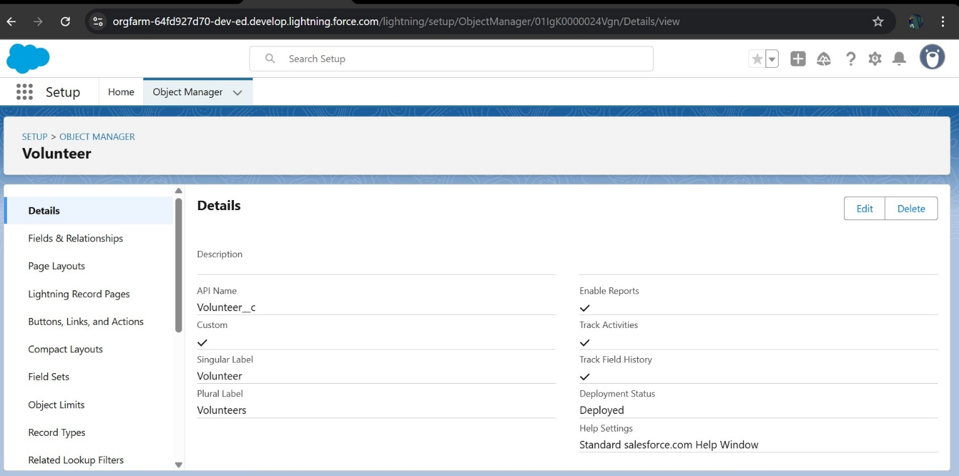

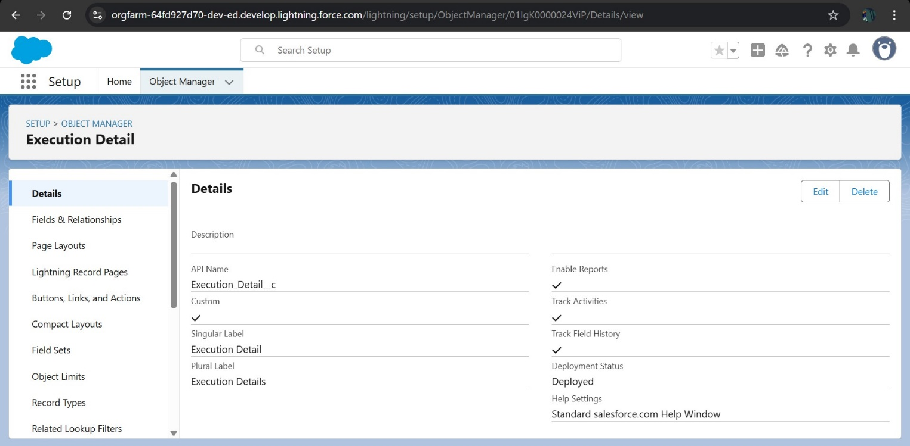

* **Created Tabs:**

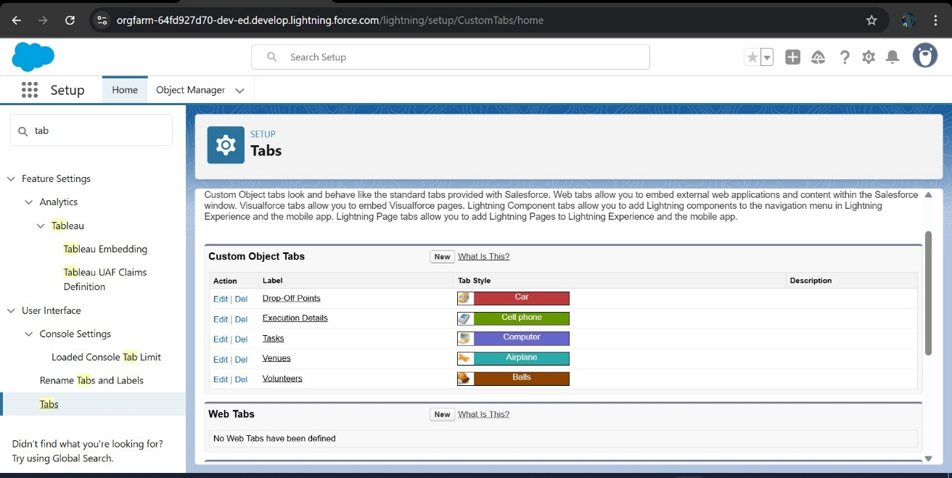

### **Created a Lightning App**

Created a HOMEPage

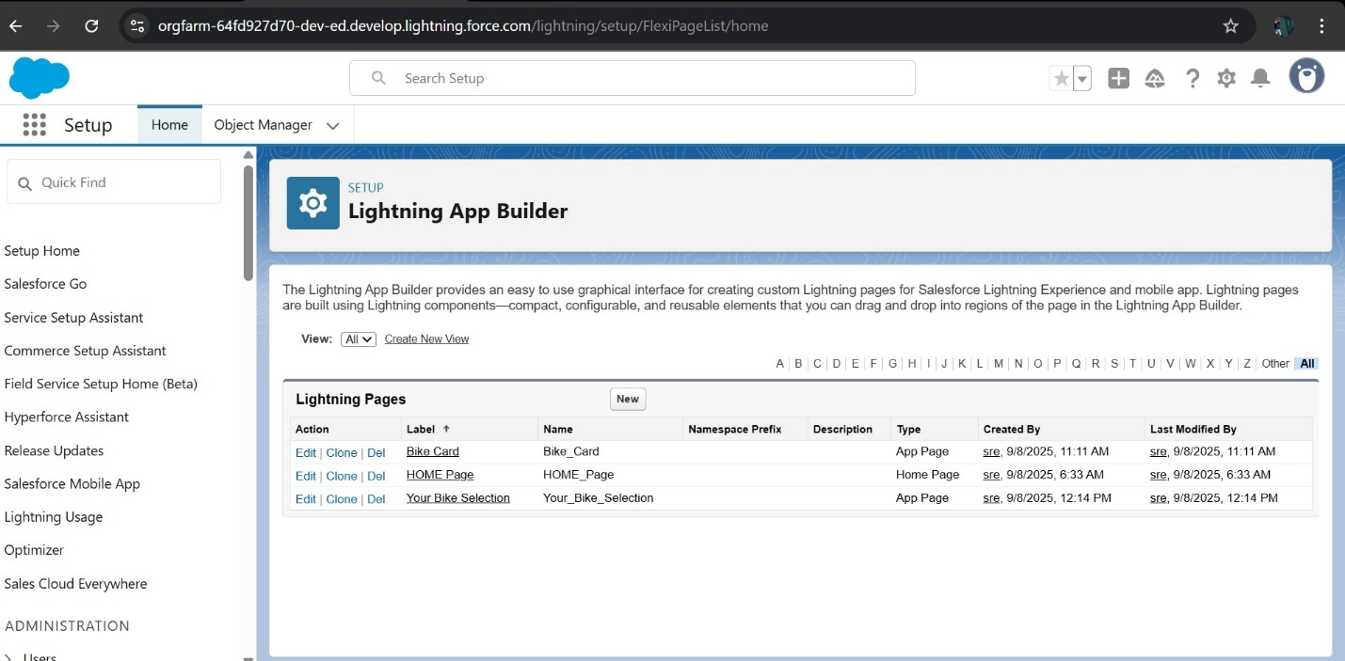

FIELDS:

### **Creation of Relationship fields in objects**

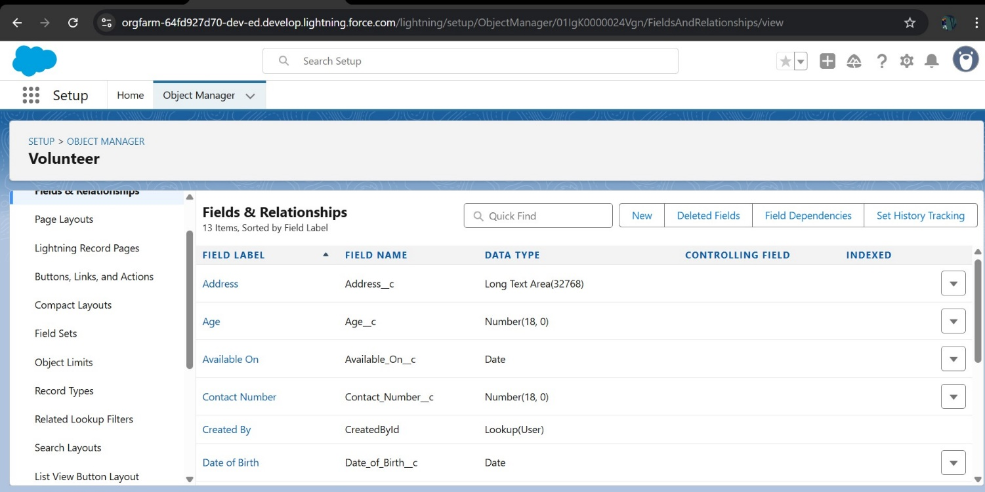

### **Creation of fields for the Venue object**

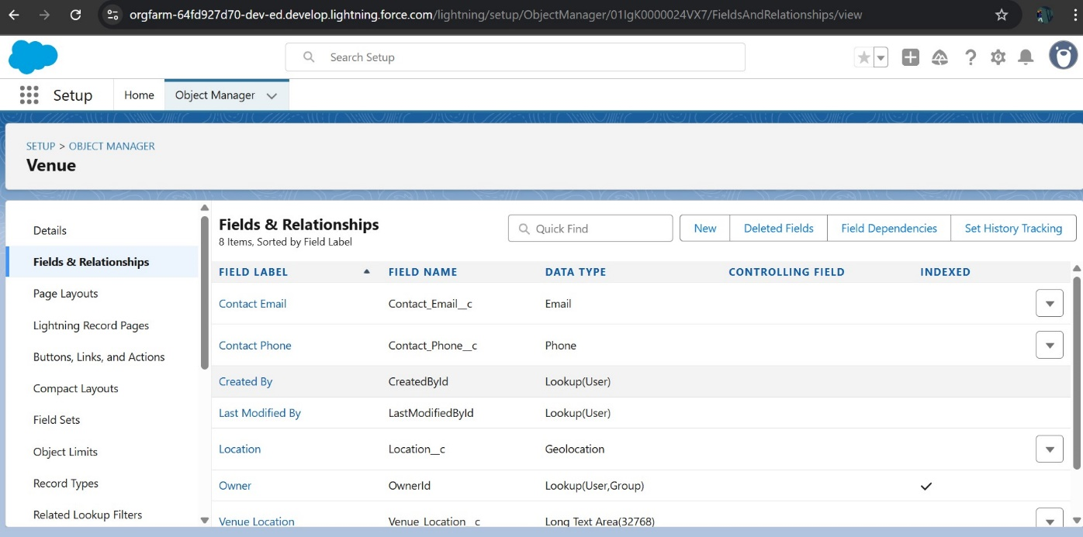

### **Creation of fields for the Drop-Off point object**

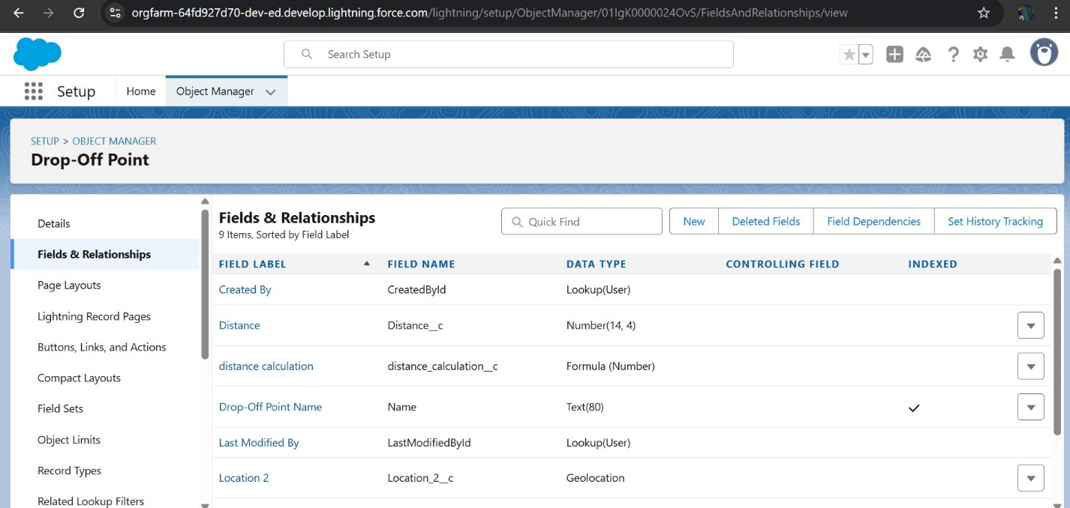

### **Creation of fields for the Task object**

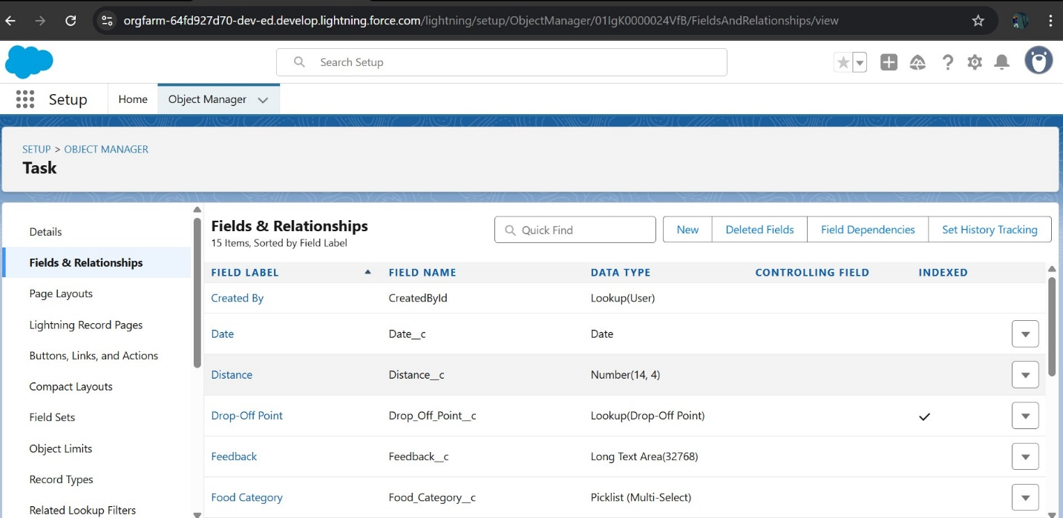

### **Creation of fields for the Volunteer object**

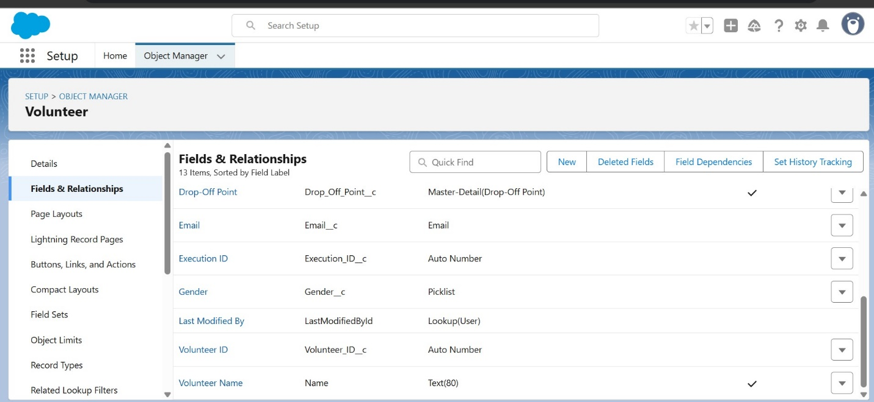

### **Creation of fields for the Execution Details object**

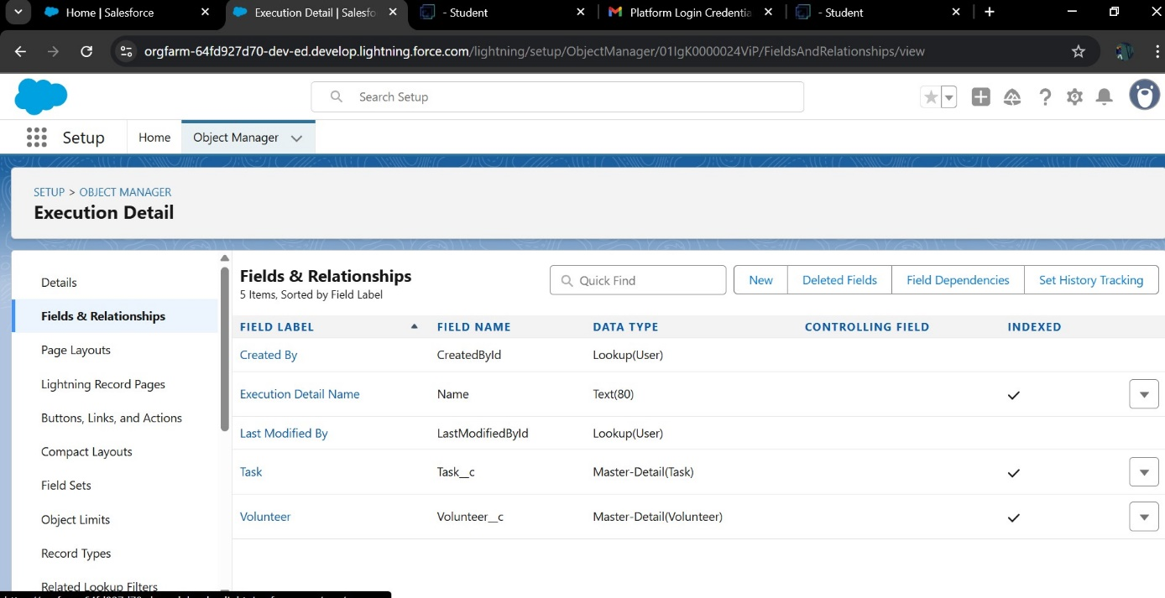

FLOWS:

### **Created Flow to create a record in Venue object**

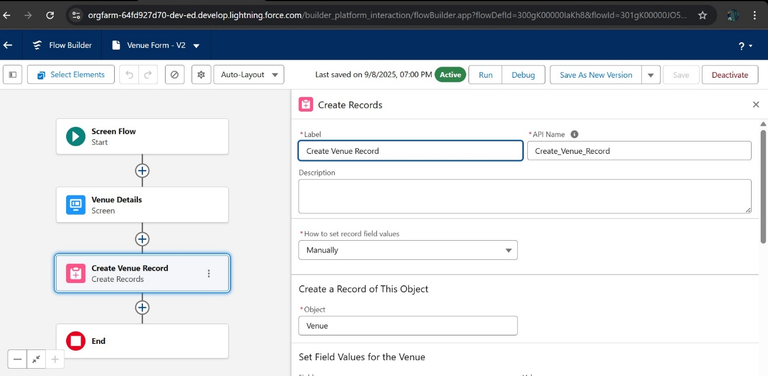

### Trigger:

### **Created a Trigger:**

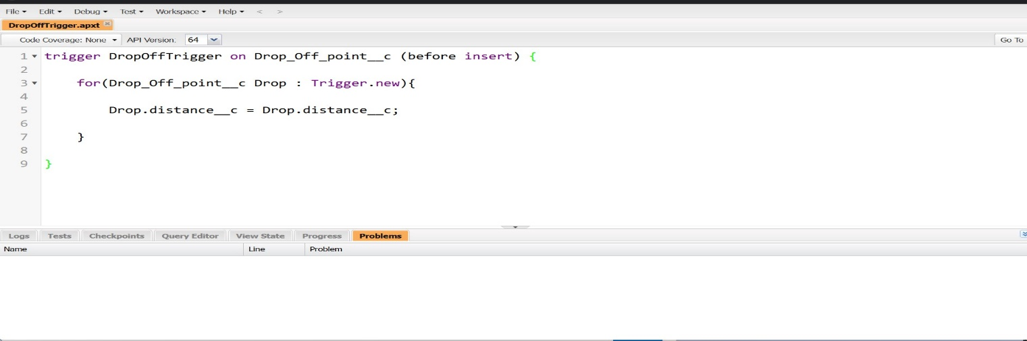

### **Trigger Code:**

trigger DropOffTrigger on Drop_Off_point__c (before insert) {

    for(Drop_Off_point__c Drop : Trigger.new){

        Drop.Distance__c = Drop.distance__c;

    }

}

### **Profiles:**

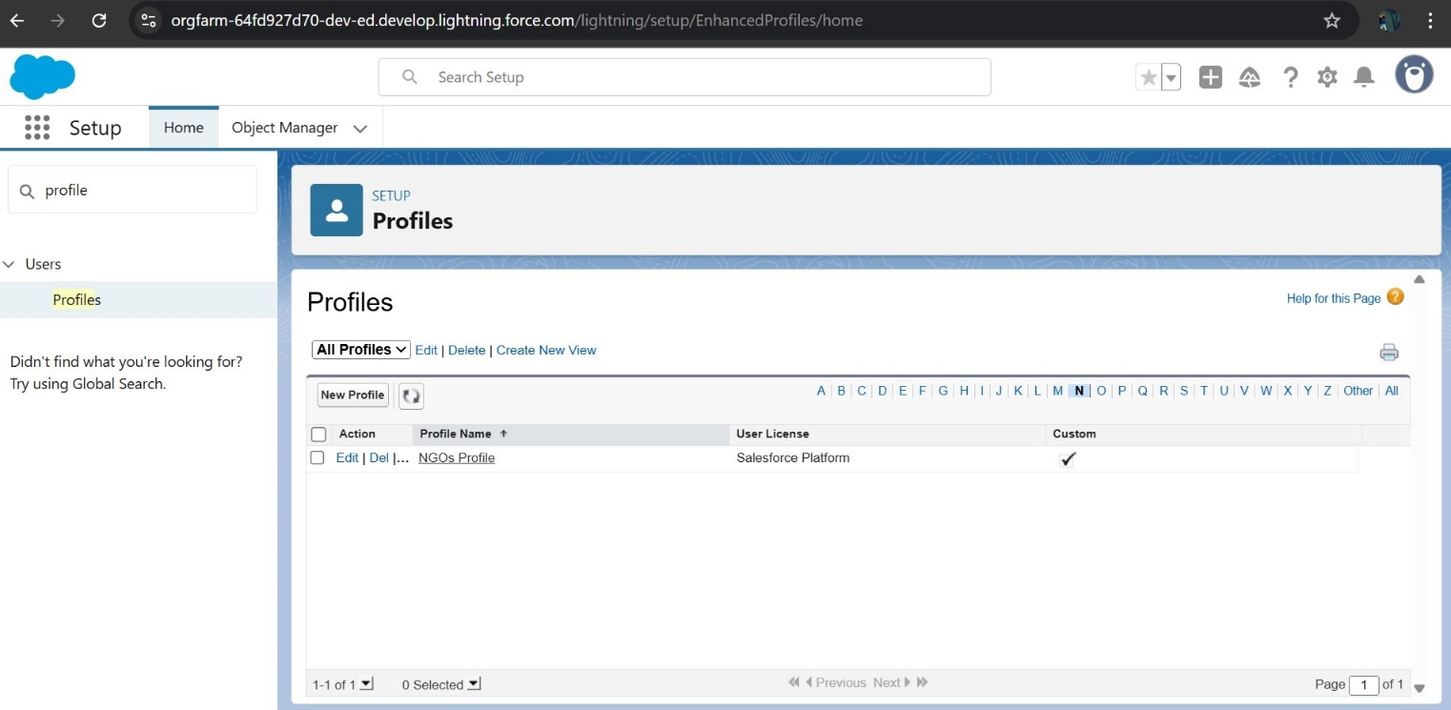

### USER:

### **Creation of Users:**

User 1, User 2 & User 3

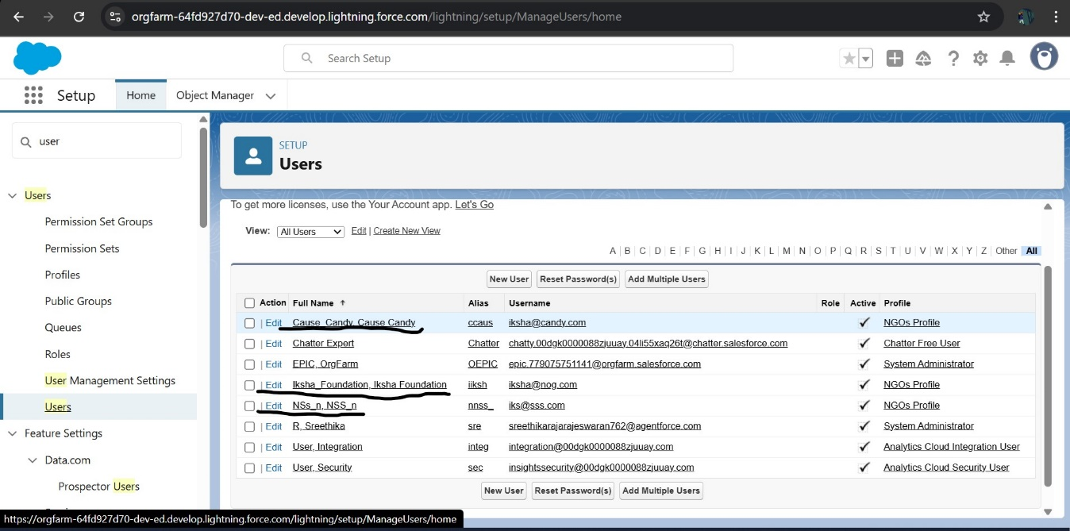

### **Public Groups:**

### Public Groups - Creation of User1,User2, User3

### 

### REPORT TYPES:

### **Creation of Report Types:**

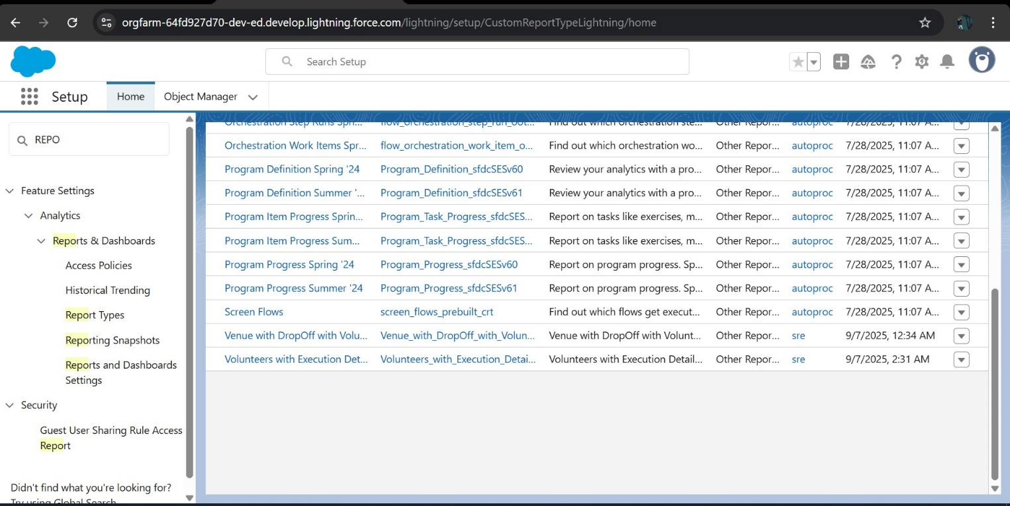

### **Reports:**

### Creation of Report on Venue with DropOff with Volunteer

### Creation of Report on Volunteers with Execution Details and Tasks

### Creation of Report on Volunteers with Execution Details and Tasks

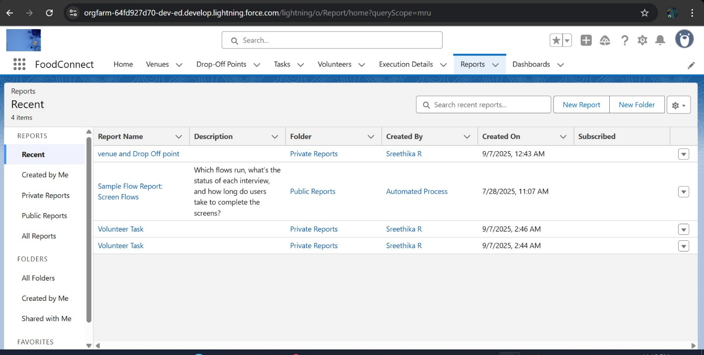

### DashBorad:

### Adding venue and Drop Off point Report to the Dashboard

### Adding Volunteer Task Report to the Dashboard

### Adding a Picture to the Dashboard (Optional)

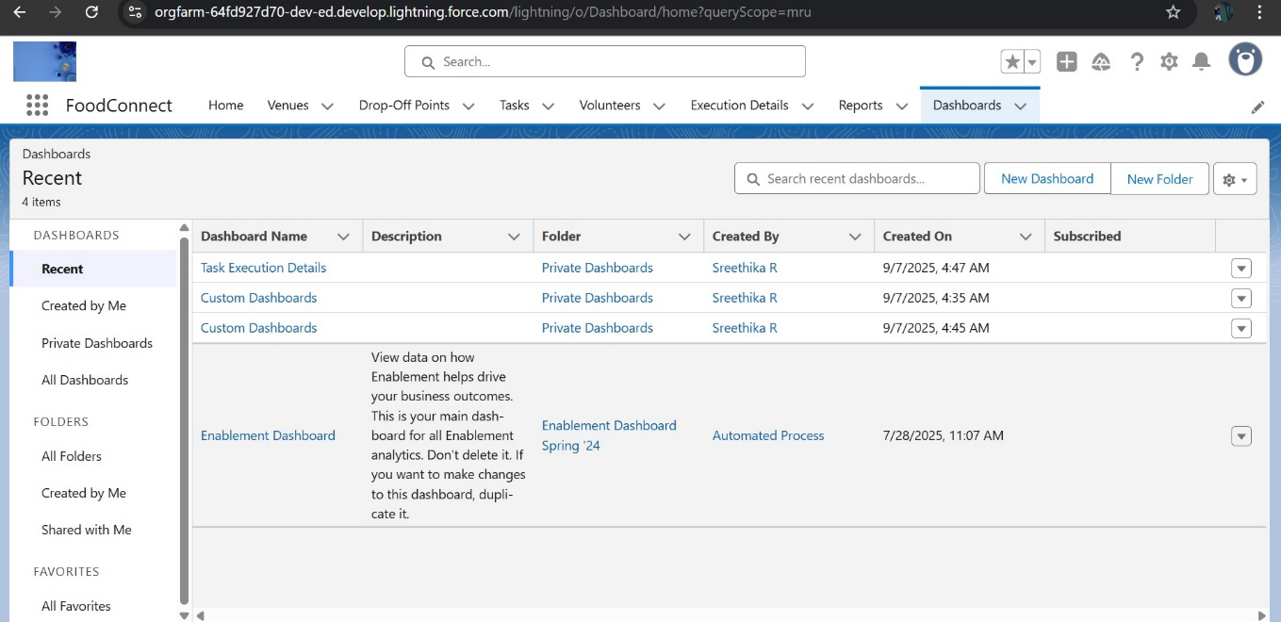

Sharing Rule:

### **Creation of sharing rules:**

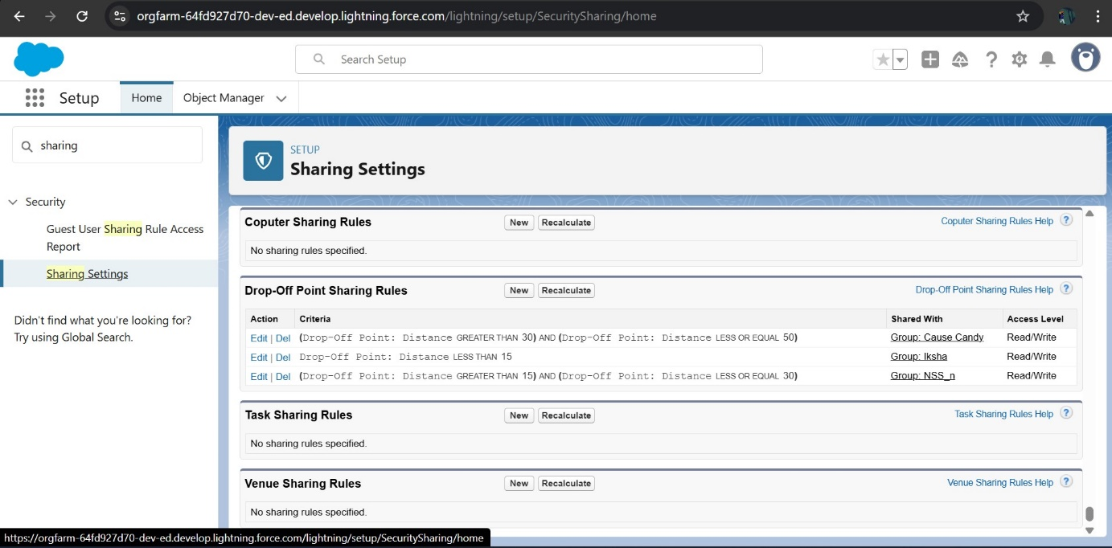

HOME PAGE:

### **Creation of Home Page:**

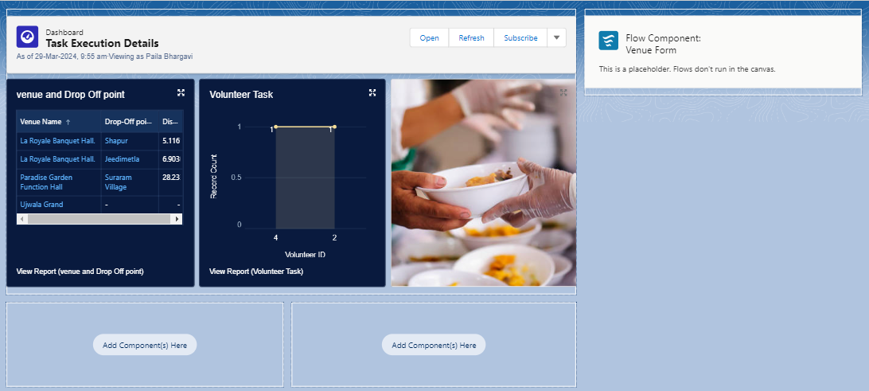

### **Conclusion**

By leveraging the Salesforce platform, the project successfully established a streamlined and transparent system for managing surplus food donations. Through efficient coordination with volunteers and timely delivery to beneficiaries, the project effectively addressed food insecurity while maximizing the utilization of available resources.